Haverhill Public Schools
Multilingual Learner Education Department

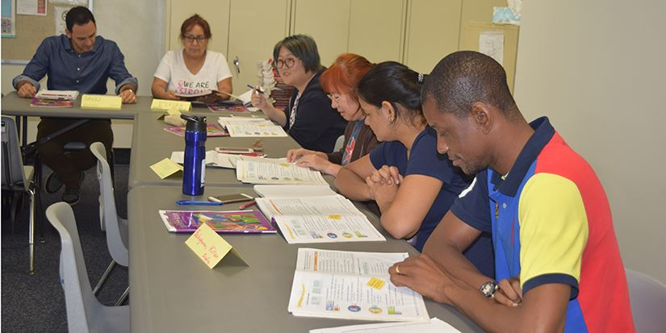
Free English Classes for Parents of Haverhill Students!

Students are welcome too !!!
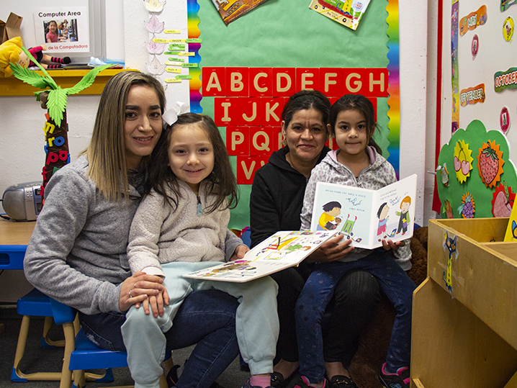
Registration Night
October 24th, 2023
Consentino School Library
6:00pm - 8:00pm

- Parents will have the opportunity to increase their English skills, computer literacy skills, and learn about HPS websites and parent portals.

- HPS students will have teacher directed homework support and enrichment activities. Parents and students will connect for 30 minutes at the end of the session for a Family Literacy experience.

- Classes will be held on Tuesday and Thursdays from 6:00pm - 8:00pm at the Consentino School.

Four sessions:

Session 1: November 9, 2023 - December 21, 2023.
Session 2: January 9, 2023 - February 15, 2024.
Session 3: March 5, 2024 - April 11, 2024.
Session 4: April 30, 2024 - June 6, 2024.

Students who miss less than 2 sessions will be invited to continue in the program.

Chromebooks are available to parent/adult learners to learn how to access HPS information.

Children of the adult ESL HPS parent must be between the ages of 5-12 to attend the program.

For more information about enrollment, contact: Jasmin Rosario at (978) 420-1945 or jasmin.rosario@haverhill-ps.org

