

**Attention Hunking Bobcats**

**There are** **days of school from**

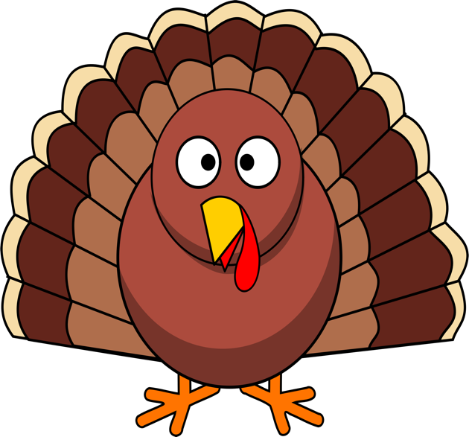

[This Photo](https://pngimg.com/download/58581) by Unknown Author is licensed under [CC BY-NC](https://creativecommons.org/licenses/by-nc/3.0/)

To

Winter Break

Thanksgiving Break

**Come every day and be entered in a raffle**

**to win prizes including Amazon Gift Cards!**

**Prizes will be given out at school December 23**

**Attend Today Achieve Tomorrow**